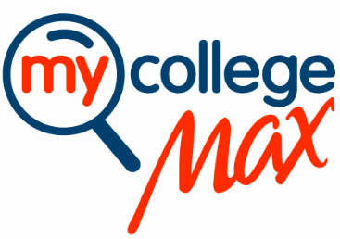
Preparing for Career Success
Presented by Award Winning Speaker
Dr. Steven Harvey

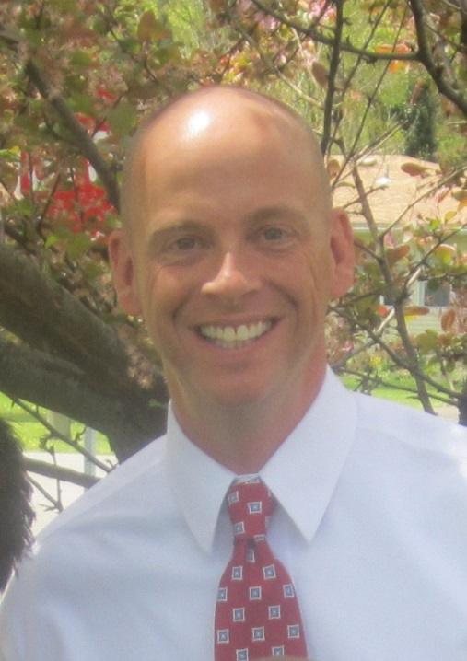
Dr. Steven Harvey is the Executive Director of the WNY Higher Education Consortium which seeks to enhance economic development in the WNY region, increase collaboration between area colleges and universities, as well as attract, engage, and retain students to the WNY area. Formerly the Vice President of Research and Program Funding for EPIC and a Senior Career Development Associate at the University at Buffalo, Dr. Harvey holds a Ph.D. in Social Foundations of Education, Master’s degree in Higher Education Administration, and B.S. in Business.

In past positions, Dr. Harvey oversaw evaluation, research, and program funding efforts and has fund raised over $20,981,404 for Western New York agencies. Dr. Harvey has conducted research in the areas of student success, student learning, college success, parenting, emotional intelligence, character education, masculinity development, college readiness, and career readiness and is published in a variety of educational, peer-review journals. In addition, Dr. Harvey is an adjunct faculty member in the Executive Leadership and Change graduate program at Daemen College and the Social and Psychological Foundations of Education Department at Buffalo State College.

Dr. Harvey has taught in higher education for over 20 years from college freshmen to doctoral candidates. He is the founder and CEO of the Center for Educational and Career Advancement, Inc. and founder and CEO of MyCollegeMax.com. Dr. Harvey is actively involved in several WNY not-for-profits and has been a member of several not-for-profit boards. In 2008, he was named to Buffalo Business First’s 40 Under 40, in 2007 he received the Buffalo State College’s Outstanding Teacher Award, and he is a member of the Leadership Buffalo Class of 2007. A native of Western New York, he and his wife and their three children reside in the Town of Clarence.

Dr. Steven Harvey of MyCollegeMax.com will speak to our students on a variety of important strategies including but not limited to:
- Teaching students the critical differences between education and career,
- Showing students the value of becoming self-directed, proactive learners, and
- Providing students 5 strategies that will prepare them to take charge of their futures in our knowledge economy.
There will be a 45 minute presentation followed by a question and answer period for students and faculty.
Location, Date, & Time Here
Hope to see you there!

